**Water Management system**

|  |  |  |  |
| --- | --- | --- | --- |
| **Issue** | **Description** | **name** | **date** |
| **1** | First Draft | Rashid Abdulrahman | 20/2/2019 |

**Complied by: RASHID ABDULRAHMAN**

**Table of contents**

1 Summary 3

2 Introduction 3

3 Definition 3

4 Proposed Concept 4

4.1 Advantages of Concept 4

4.2 Design criteria 5

5 Detail design 5

5.1 Material Selection 5

5.2 Simulation 9

6 Simulation/Testing 10

7 Errors and Faults 15

7.1 LCD initiation 15

7.2 Memory leak error 15

8 Compliance checklist 16

9 Conclusion 16

10 User Guide 17

10.1 Setting up Arduino 17

10.2 Setting Up Johnny-five 18

10.3 Run code 19

11 Reference 20

# Summary

From personal experience, it was noticed that at my house in Africa a lot of water and electricity go to waste due to the lack of water management system. In our day to day’s activities, it is common to have shortage or overflow of water in the house and in a country where power cuts frequently occur this is critical.

Current system in the house consists of well, reserve tank, supply tank and 2 dc motors to pump water around. The first motor is placed in a well to pump water into a reserve tank and the second motor is used to pump water to a supply tank, both motors need to manually turned on and off when they need to be and if someone fail to turn off the motor in time it might may cause water spillage and at times the individual might not know that the water level has dropped so low until the tank is completely emptied.

This report the Detail Design Process taken on in developing a final product that can manufactured. The report outlines the optimum concept, design criteria, questionnaire plus results, manufacturing methods, costing, CAD drawings of the circuit diagrams, standard components, environmental concerns, compliance checklist from where all information is supplied for the indicator to be manufactured.

# Definition

**LCD – Liquid crystal display**

PCB – Printed Circuit Board

Sensor – HC-SR04

# Proposed Concept

In this section a concept for Water management system is introduced. This method shall use a sensor which is place on top of the tank facing down. The sensor shall be used to measure the water level

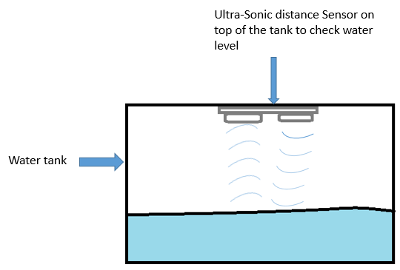

Figure 1

## Advantages of Concept

i. LCD can show a precise distance between the water and sensor.

ii. Motor can be automatically operated

iii. The system shall maintain the water level

## Design criteria

The water pump management system is required to meet all design criteria. The table below contain the most important criteria that the designer needs to meet in order to ensure that the system is fit for purpose.

|  |
| --- |
| **Design Criteria** |
| The circuit shall turn on the motor in the reserve tank when water reaches critical point |
| The circuit shall turn off the motor in the reserve tank when water is full in the reserve tank |
| The circuit shall turn on the motor in the supply tank when water reaches critical point |
| The circuit shall turn off the motor in the reserve tank when water is full in the supply tank |
| A sensor shall read the distance between water and sensor in the reserve tank |
| A sensor shall read the distance between water and sensor in the supply tank |
|  |
|  |
|  |
|  |
|  |

# Detail design

In this section, the optimum design shall be taken in series of steps that are going to be use in creating the functional product. These steps focus on general aspects such as research, conceptualization, and feasibility assessment, establishing design requirements, detailed design and production costs.

## Material Selection

### Arduino Uno

Arduino Uno is a microcontroller board that handles the inputs and outputs. This allow users to connect physical components to a digital world. Arduino Uno can be controlled using a code that has been written on a development environment such as Arduino IDE and transfer it to the microprocessor using a usb port that connect to a computer. That code then stays in the controller memory until it is replaced, at any point when the power is supplied to the Arduino the code will continue to cycle. Arduino Uno consists of 14 digital input and output pins and 6 analog pins.

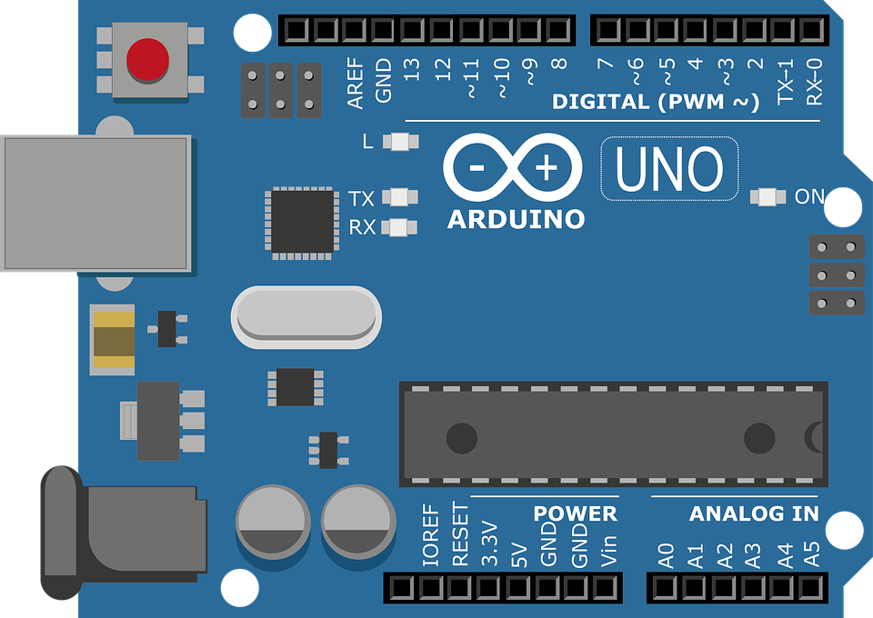

Figure 2

### LED selection

Blinking LEDs are going to be used. A blinking LED includes a tiny integrated circuit (IC) built into the LED itself. ‘Most blinking LEDs have a forward volt of between 1.8 – 2.2 volts and a forward current of 20 mA to 30 mA. Because most electronic components come with a wide tolerance band as shown in Figure 4, therefore an average of 2 volts and 25 mA is going to be used in calculations’ (Farnell.com, 2018).

All LEDs are polarized, which means it has positive and negative leads, a positive (anode) and a negative (cathode) which need to be connected correctly in the circuit. On diagrams, its symbol is similar to the simple diode, with two arrows pointing outwards. The anode (+) is marked with a triangle and the cathode (-) with a line.

There are several ways to identify the leads of an LED:

1. The cathode (negative) is usually marked with a flattenededge on the bottom of the LED's body as shown in figure 3.
2. A longer lead is the positive (anode) and the shorter lead is the negative (cathode).

LED pinout and schematic symbol

Figure 3

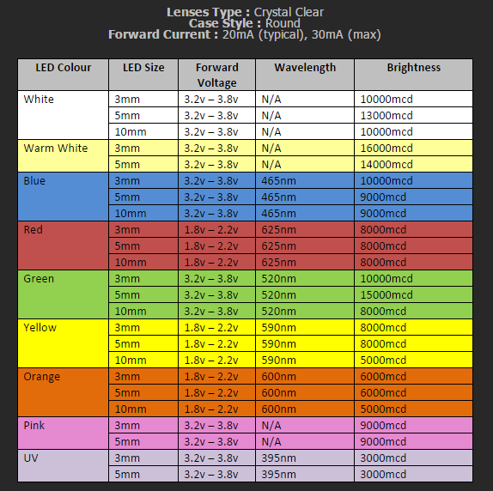

Figure 4

### Resistors

All LEDs require some form of current limiting. Connecting an LED directly to the power supply will burn it out in an instantly. Overdriving, even briefly, will significantly reduce life and light output of the LED.’ Driving a single or a string of low current (20-30 mA) LEDs is a simple task, this can be done by adding a small resistor in series. This is the easiest and cheapest way to limit the current. The resistance of the resistor and its tolerance are marked on the resistor with colour code bands that represents the resistance value. There are three types of resistor colour code’ (Learn.sparkfun.com, 2018).

* 4 bands: digit, digit, multiplier, tolerance.
* 5 bands: digit, digit, digit, multiplier, tolerance.
* 6 bands: digit, digit, digit , multiplier, tolerance, temperature coefficient

### LCD 16x2

A liquid crystal display is a mix of two conditions of matters, the solid and liquid. LCD uses a liquid crystal to produce a visible image. LCD operates by applying a varying electric voltage to a layer of liquid crystal, thereby inducing changes in its optical properties. LCDs are commonly used for electronic billboards as monitors and in flat panel televisions. For this project a 16x2 LCD display shall be used to display different variables.

16x2 LCD has 32 characters in total, 16in 1st line and another 16 in 2nd line. Each character in the display has approximately 50 pixels so to display one character all 50 pixels must work together.

‘16x2 LCD consists of 16 pins, 2 of which are power pin(VSS and VDD), contrast control pin (VEE) which controls the thickness of the characters shown, 3 control pins (RW,RSS and E), 2 backlight pins(BL+ and BL-) and 8 inputs/data pins(D0-D7)’ (Garcia and LIng, 2018) .

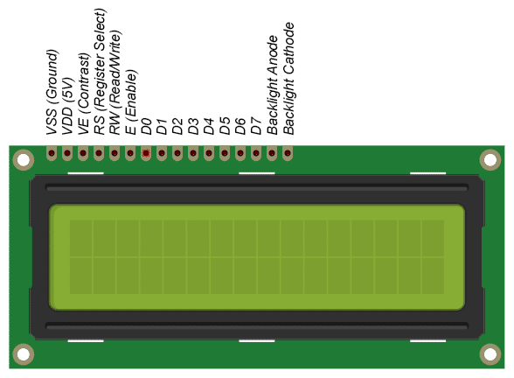

Figure 5

### HC-SR04

HC-SR04 is an ultra-sonic distance sensor is a device that uses an ultrasonic sound in order to measure the distance between itself and the nearest object. This sensor consist of 2 ultrasonic transducers where one is used as a transmitter and the other one is used as a receiver. ‘A transmitter emits/sends out a series of ultrasonic pulses and these pulses are received by the receiver after they have hit the nearby object and bounce back the signal, the time delay between the transmissions and receiving the signal is used to calculate the distance so a longer time delay will be a longer distance and a shorter time delay will be a short distance. HS-SR04 can be operated using 4 pins labelled as VCC, TRIG , ECO and GND where VCC is a 5 volts power pin, TRIG is a trigger pin which is an input pin, ECO is an echo pin which is an output pin and GND is a ground pin’ (Arduino Project Hub, 2018).

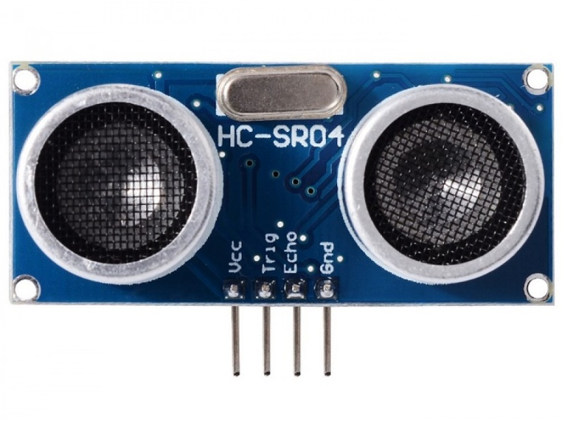

Figure 6

## Simulation

A simulation is a model that imitates the operation of a proposed system. An intelligent software such as proteus simulator can be used to build a visual sample that appears or feel close to the real model, by adding/connecting components and restrictions that makeup a proposed system can represent a desired model.

### Simulation Model

Below is a proposed water management system model that was created using proteus 8.6 to mimic the behaviour of the water management system. A system below consists of 1 Ultrasonic sensors, 3 LEDs, 4 resistors . the sensor shall be used to mimic the distance range between sensors and water using Arduino Uno. Arduino program REF[…] shall be created on visual studio code and inserted into proteus software to observe the behaviour of the system

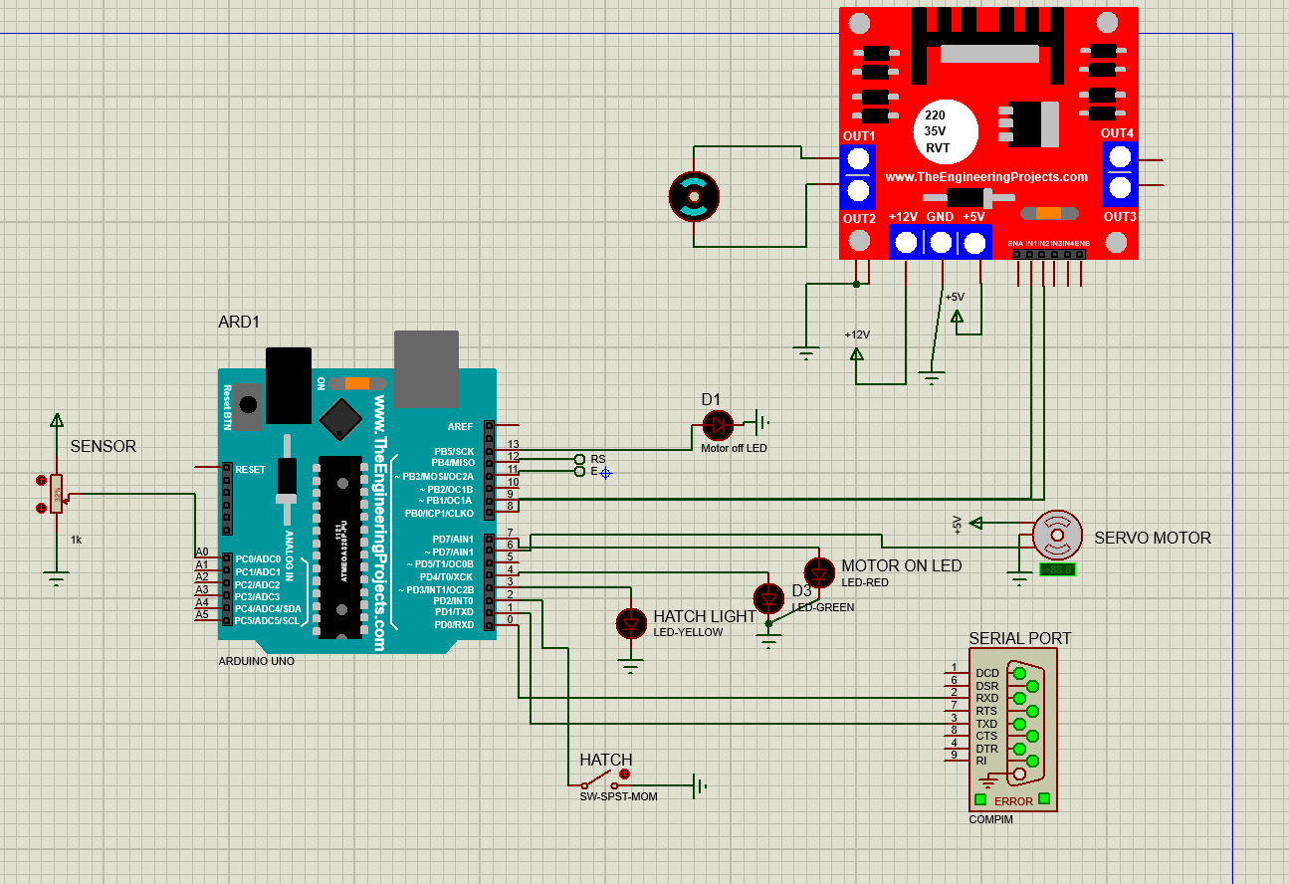

Figure 7

# Simulation/Testing

Testing is a vital stage in the project development not only for proving the design and highlighting potential problems early in the development cycle. Excellent communication channels between design and production are essential to successfully manufacture and address any issues that arise during production, in order to meet any requirements. The first few tests were carried out using proteus simulation program to check the function of the Arduino code and how every component behaves.

### Simulation 1

The first simulation was carried out on proteus simulator to simulate the function of the motor in regarding to sensor reading. once the program is initiated using console, it shall check for sensor read and if the reading is above 300 motor shall stay off and motor off LED shall turn on to …… state of the motor otherwise if the reading is below 300 moor shall turn on and motor on LED shall turn on

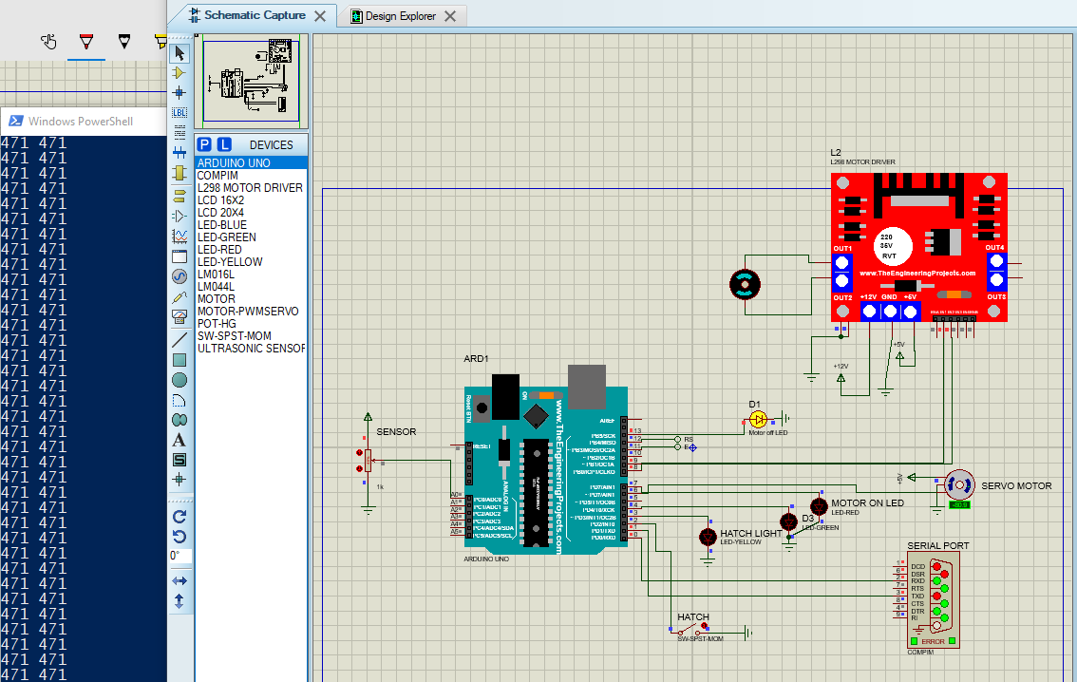

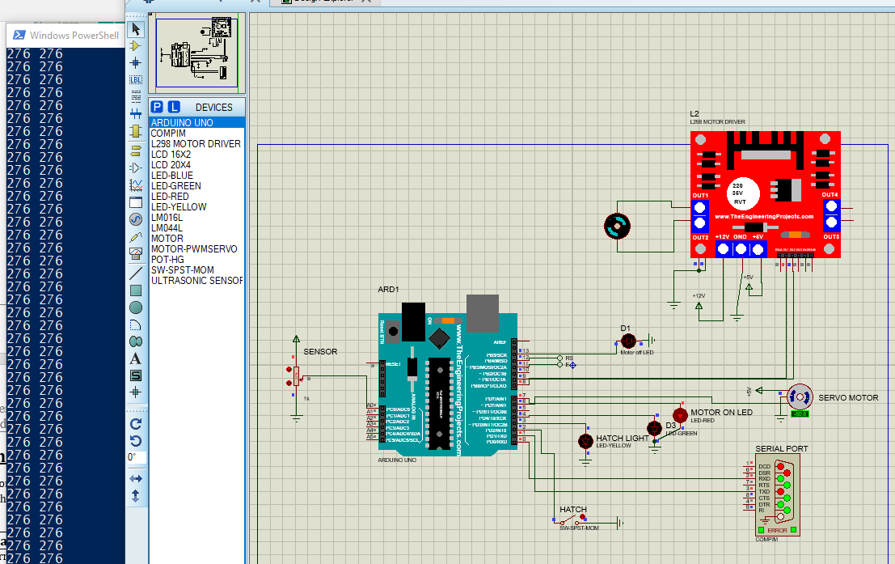

### Simulation 2

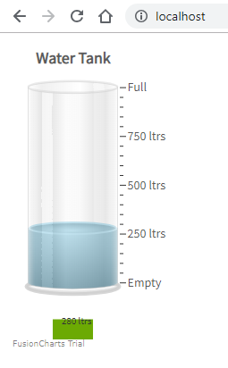The second part of simulation was to create a webpage that consist of a tank gauge that reads analog inputs from the Arduino and render the tank depending on the input

### Simulation 3

This part of simulation was to create buttons on a webpage button that shall transmit signals to the Arduino.

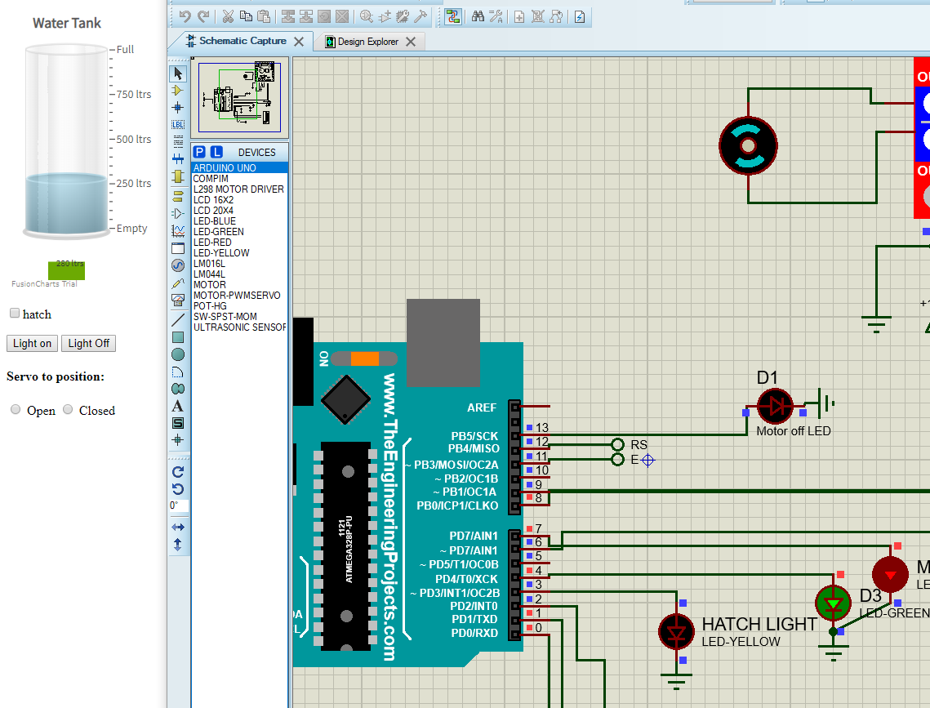

Figure above shows green LED being controlled (ON/OFF) via a webpage light on or light off button

### Simulation 4

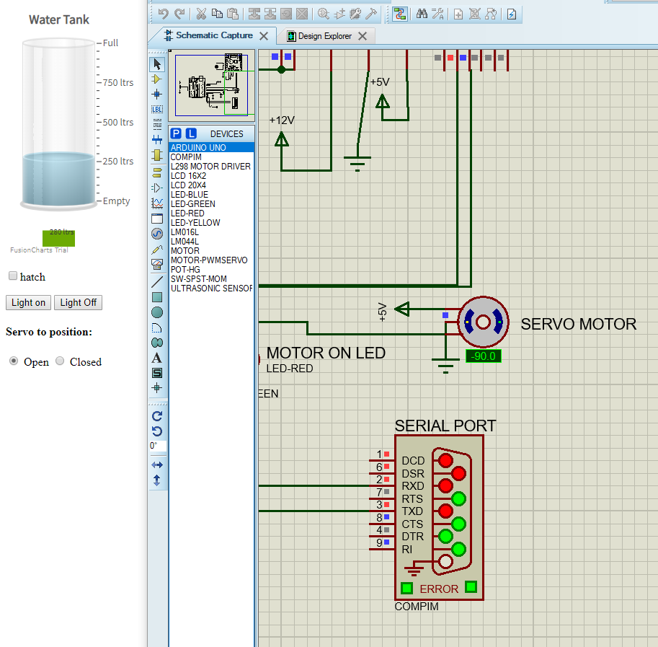This part of simulation was to create a servo motor that shall be connected to a draining tap, this servo motor shall be opened or closed via a webpage

Figure above shows a simulation of a servo motor being sent to 90 degrees (open tap position) via a webpage

### Simulation 5

This part of simulation was to add LCD display that shall display water level and motor state locally, after doing research it was noted that the display can not be operated using analog pins on the Arduino Uno there for a new circuit had to be designed using Arduino Mega board as it consists of more digital pins

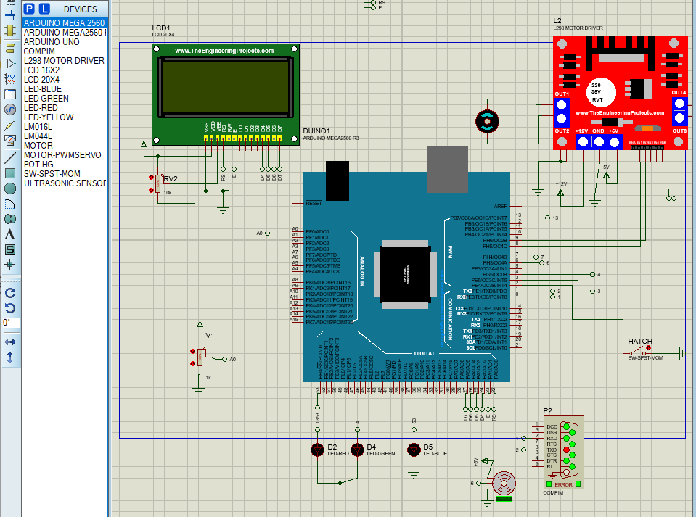

Figure above shows an LCD display being added into the new circuit using Arduino Mega board

# Errors and Faults

This section contains some of the errors and faults that occurred during the simulation process

## LCD initiation

LCD display could not be initiated using analog pins on the board using johnny five library and there for when an analog pin was activated it shows up as a string/function rather than pin

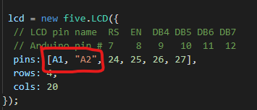

## Memory leak error

After adding an LCD to a circuit, a memory leak error started to appear and this caused the program to stop transmitting or receiving signals even though the LCD was initiated locally and there were no listeners connected to LCD

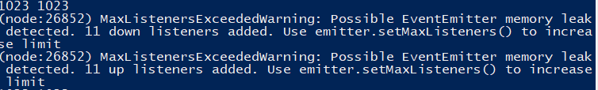

# User Guide

This section contains information that is needed to initiate a given program

## Setting up Arduino

First connect your Arduino Uno to your computer with a USB cable. Meanwhile, download the Arduino IDE and install it on your computer. You will need the IDE only for the initial setup.

On Arduino IDE, go to Tools > Port and make sure the right board, Arduino Uno, is connected to the right port

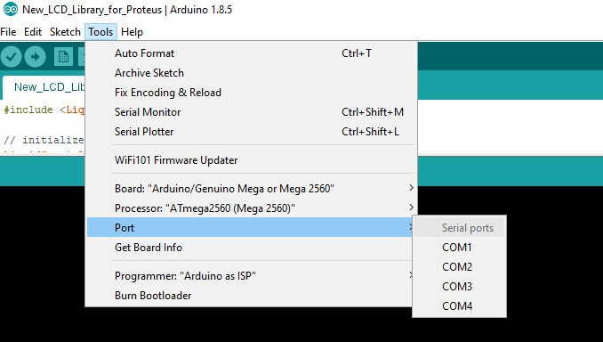

On IDE, open File > Examples > Firmata > StandardFirmata.click the upload button.

Wait until the IDE message window display “Done uploading”.

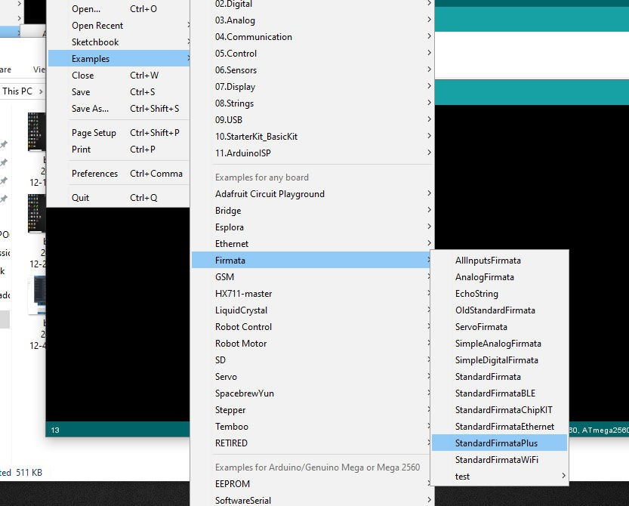

## Setting Up Johnny-five

Before proceeding, a latest version of Node.js is installed on a computer and package.json file is in the file directory with below information

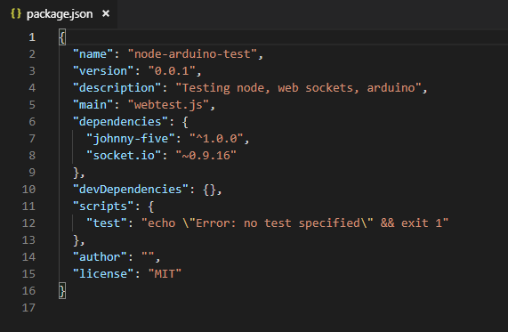

Cd into the file directory and install Johnny-five using npm package manager

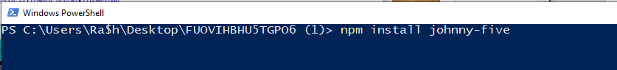

## Run code

Type in node “file name.js” and click enter



Webpage can be accessed though <http://localhost/> once the program has been initiated

